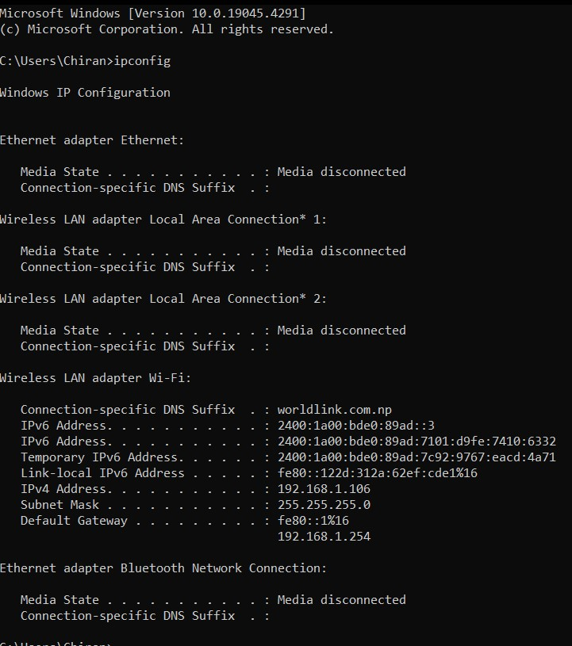

**IP Address is** IPv4 Address ………………………………………….: 192.168.1.106

**Subnet mask** Subnet Mask…………………………………………..: 255.255.255.0

**Network Address**

IP Address : 11000000.10101000.00000001.01101010

Subnet mask: 11111111.11111111.11111111.00000000

AND: 11000000.10101000.00000001.00000000

Network Address is ……………………………………………. 192.168.1.0

254 nodes are supported by this network.